**A PROJECT REPORT ON**

**CLINICARE**

**(A Primary Health Care Web Application)**

**Submitted By**

**TEAM BUSY-BEES**

**Vikas P (NEC 09 14 050)**

**Vishnu K N (NEC 09 14 051)**

**June 2017**

**Submitted in the fulfillment of the requirements of the Award**

**of**

**Diploma in Information Technology**



**NETTUR TECHNICAL TRAINING FOUNDATION**

**#40/40A, Electronic City,**

**Hosur Road, Bangalore-560 100**



**NETTUR TECHNICAL TRAINING FOUNDATION**

**#40/40A, Electronic City,**

**Hosur Road,**

**Bangalore-560 100.**

**CERTIFICATE**

Certified that the project work entitled “CLINI CARE” carried out by VISHNU K N and VIKAS P ,a bonafide student of NTTF in partial fulfillment for the award of Diploma in Information Technology of the Nettur Technical Training Foundation,Bangalore during the year 2014-2017.It is certified that all corrections/suggestions indicated for Internal Assessment have been incorporated in the report deposited in the department library.The project report has been approved as it satisfies that the academic requirements in respect of project work prescribed for the said Diploma.

Project Guide Course In-charge Principal

Name of the Examiner’s Signature with date

1.

2.

**SYNOPSIS**

**Introduction**

In today's World We have many tourists visiting our cities and also there are people coming for work in Our City. There happen some emergency situations where these people may need the Medical Assistance. Our CLINICARE is the best solution for such people in Bangalore who need immediate Medical Guidance.

The CLINICARE is an On-line Medical Assistance where people can gather information about the Medical Supports near them.

**ACKNOWLEDGMENT**

An endeavor of this magnitude is never accomplished in isolation. We are deeply indebted to a number of people notably :

First of all we are thanked to **Mr. Giridharan R**, Principal NTTF Training Center NEC- Bangalore and **Mrs.Jasmin**, Vice-Principal NTTF Training center NEC- Bangalore for being a source of inspiration throughout our project.

We owe great to **Mr. Ramkrishnanand**, Academic In-charge in the project work.

We are indebted and grateful to **Mrs. Rijina P**, Our Project In-charge, Our Project Guide **Mrs. Prabha** and **Mr. Shakeel**, Our Subject-In charge , guide for valuable guidance at each and every stage of Our Project.

With deep sense if gratitude We express Our heartfelt thanks to **Mrs. Deepa**, **Mrs. Soumya**, and all other Staff Members who gave valuable suggestions and constant encouragement for successful fulfillment of the project.

Finally we thank one and all who helped us in directly and indirectly for the completion of the project.

**CONTENTS**

1. **Introduction**
   1. Title of the project
   2. Group Name
   3. Group Leader
   4. Group Members
   5. S/W & H/W Configuration
   6. Technology used
   7. Project Description
   8. Project Modules
   9. Project Plan
2. **SRS Document**
3. **System Design**
   1. Control Flow Diagram
   2. Data Flow Diagram
   3. Entity Relationship Diagram
   4. Use Case Diagram
   5. Database Design
   6. Data Dictionary
   7. Gantt Chart
4. **Snapshots**
5. **Source Code**
6. **Reports, Test plan, Test case, Bug Report**
7. **Future Enhancements of Project**
8. **Bibliography**
9. **Conclusion**

**1. INTRODUCTION**

**1.1 TITLE OF THE PROJECT :** CLINICARE

**1.2 GROUP NAME :** BUSY-BEES

**1.3 GROUP LEADER :**

**1.4 GROUP MEMBERS :**

Vikas P (NEC 09 14 050)

Vishnu K N (NEC 09 14 051)

**1.5 S/W & H/W CONFIGURATION**

**SOFTWARE REQUIREMENTS:**

Front End  JSP, HTML5, CSS

Database  MySQL

Scripting language  J query, Bootstrap

Web Server  Apache-tomcat Server 6.0

Operating system  Windows-8.1 or Above

IDE  Net Beans 8.1 , Notepad++

Third Party Software  Twilio SMS Gateway

Social Services  G mail Services for sending mail

Browsers  IE8/8+, Chrome15+, Safari 4+,

Mozilla Firefox

**HARDWARE REQUIREMENTS:**

Processor : Intel i3 and above

RAM : 2 GB and above

Hard Disk : 500 GB and above

**1.6 TECHNOLOGY USED**

J2EE, JSP, HTML5, MySQL

**1.7 PROJECT DESCRIPTION**

The Project CLINICARE is a complete medical assistance where the user can approach our web application to enroll in complete Medical Guidance in the Cities of Bangalore.

The Main Objective of our CLINICARE is to guide the people who are new to the city to any medical centers in case of emergency. Also people will get information about certain medical camps conducts by charitable, hospitals etc.

**1.8 PROJECT MODULES**

The modules present in CLINICARE are:

*ADMIN:*

LOGIN

VERIFY DOCTOR AUTHENTICATION

EDIT/UPDATE MED CAMPS

EDIT/UPDATE BLOOD DONORS

LOG OUT

*USER:*

TAKE DOCTOR APPOINTMENTS

VIEW BLOOD DONORS

ADD BLOOD DONORS

VIEW SERVICES

VIEW MED CAMPS

INFORM MED CAMPS

*DOCTOR:* LOGIN

VIEW APPOINTMENTS

UPDATE LEAVE

LOGOUT

**Module Description:**

APPOINTMENTS:

In this module the user can take the doctor's appointment nearby their location. To take the appointment the user should fill up and submit the Registration form with their mobile number and when they finish their appointment, a message with the time and schedule of the appointment will be sent to their mobile phone.

BLOOD BANK:

This module gives the detail about the blood donors. The users can view the nearest blood banks and the blood donors by selecting the location and the blood group. The module also has a registration for the users who are willing to donate their blood.

DOCTOR'S LOGIN:

This module is for Doctors. The Doctor Should Login with the login credentials issued by the Admin. Once they login they can View the Appointments of the day, the doctors can update their leaves and Update and Edit their records.

SERVICES:

The module is about the details of Medical Stores and the Laboratories near your location .Users can also find the Ambulance Service in this Module.

MEDICAL CAMPS:

Users can see the details of free check up and medical camps in the City. The Module also has the facility to upload or inform details of any upcoming Medical camps.

**JSP:**

* JSP pages are components in a web or J2EE application that consists of HTML and Java code
* Code in a JSP can access data across the entire web application and can use server-side resources such as databases, directories, and other application components.
* JSP pages are dynamic because they can contain Java code, which can process the request and tailor the response based on the request. All the power of Java sits behind every JSP page.
* JSP is easy to learn and allows developers to quickly produce websites and application in an open and standard way. JSP is based on Java, an object oriented language. JSP offers a robust platform for web development.

Main reasons to use JSP:

1. Multi-Platform.
2. Component reuse by using Java Beans and EJB.
3. Advantages of Java.

**MySQL:**

MySQL is a database which helps us to store data in large amount and retrieve when required. It is major used for the server side storage in most of the project which also take cares with the security by login.

This also easy to create, update, delete, insert and perform other operations when required easily. The database created can be easily taken as back up and restored in any place again and executed. Backup of information can be taken in the MySQL.

The Oracle relational database management system (RDBMS) provides an open, comprehensive, integrated approach to information management.

This is accomplished while delivering high performance. At the same time, it prevents unauthorized access and provides efficient solutions for failure recovery.

**TESTING:**

Testing must be done with proper planning as the system testing is very expensive for large systems, huge amount has spent for testing.

Test planning is concerned with setting out standards for the testing process, rather than describing product tests. Error may begin to occur the very inspection of the process whether the objectives may be imperfectly specified, as well as later design and development stages.

After the source was ready, the application was tested to uncover as many errors as possible. Tests were conducted to:

* Examine the internal logic of the application components/Elements.
* Examine the input and output domains of the program to Uncover errors in the program functions and performance.

**2. SOFTWARE REQUIREMENT SPECIFICATION (SRS)**

**Advantages:**

* Users can easily locate clinics and take the doctor appointment
* Medical assistance in major locations
* Information of Medical camps
* Users can search and find blood donors in their location

**Purpose:** Clinicare is a web application for the people to locate and find out the nearest clinics, blood donors and medical stores and laboratories.

**Scope:** There is no existing application like Clinicare. The only existing applications are hospital management system, which can only give access to the availability with in that hospital.

**Drawbacks:**

* In such hospital management systems, users can only take appointment for the doctors available in that particular hospital.
* Medical details will be limited within the particular hospital.

**3. SYSTEM DESIGN**

**3.1 BLOCK DIAGRAM (BD)**

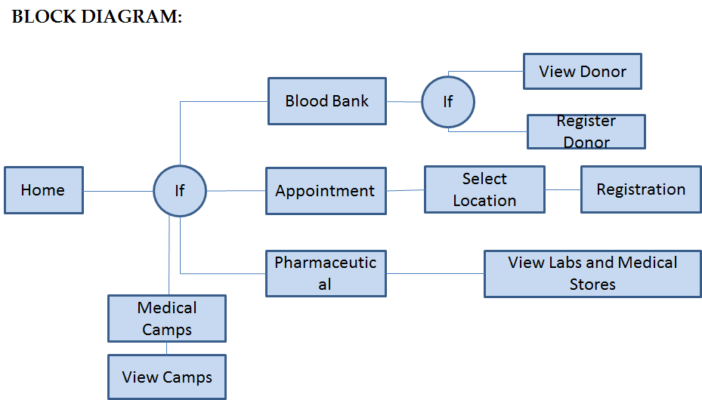

**3.2 DATA FLOW DIAGRAM (DFD)**

A data flow diagram (DFD) is a graphical representation of the "flow" of data through an information system, modelling its *process* aspects. A DFD is often used as a preliminary step to create an overview of the system without going into great detail, which can later be elaborated. DFDs can also be used for the [visualization](https://en.wikipedia.org/wiki/Data_visualization) of [data processing](https://en.wikipedia.org/wiki/Data_processing) (structured design).

A DFD shows what kind of information will be input to and output from the system, how the data will advance through the system, and where the data will be stored. It does not show information about the timing of process or information about whether processes will operate in sequence or in parallel unlike a [flowchart](https://en.wikipedia.org/wiki/Flowchart) which also shows this information.

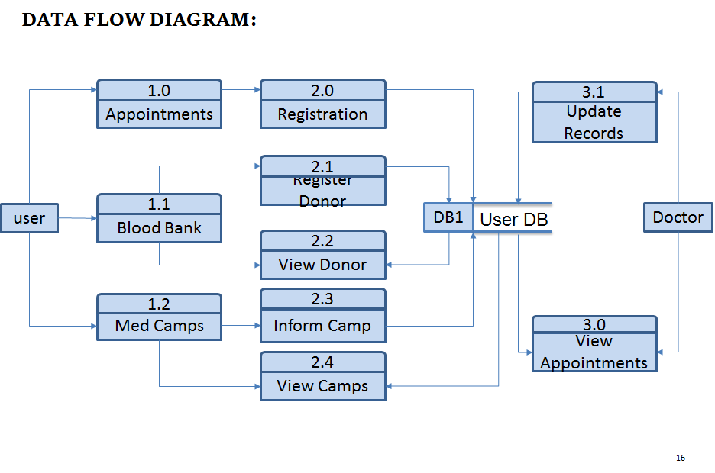

**3.3 ENTITY RELATIONSHIP DIAGRAM (ERD)**

An entity-relationship diagram (ERD) is a data modeling technique that graphically illustrates an information system's entities and the relationships between those entities. An ERD is a conceptual and representational model of data used to represent the entity framework infrastructure.

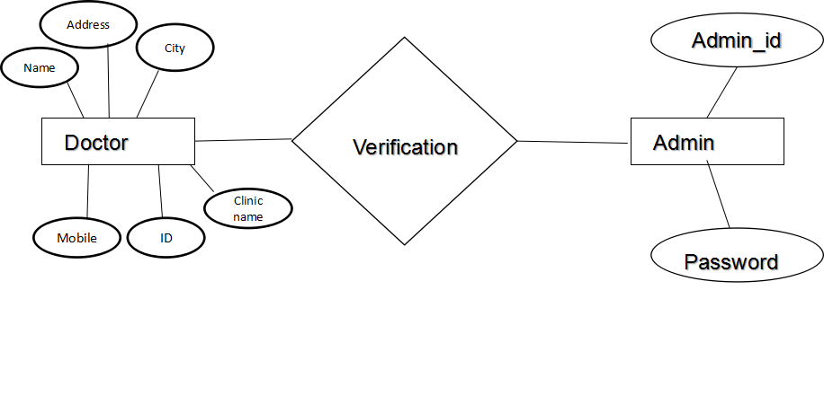

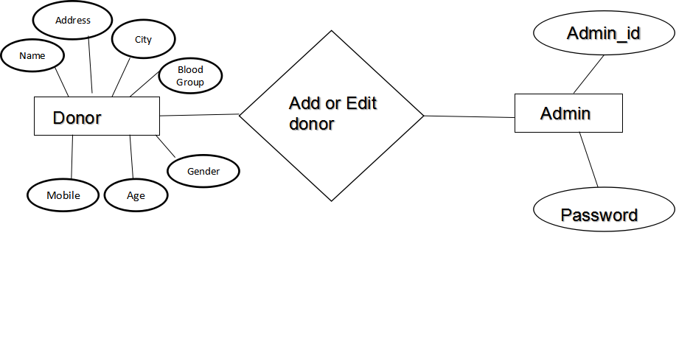

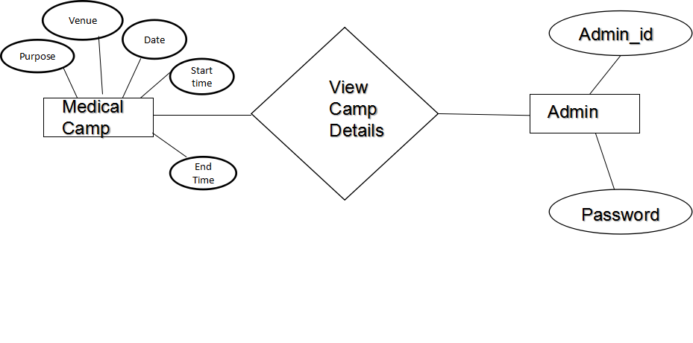

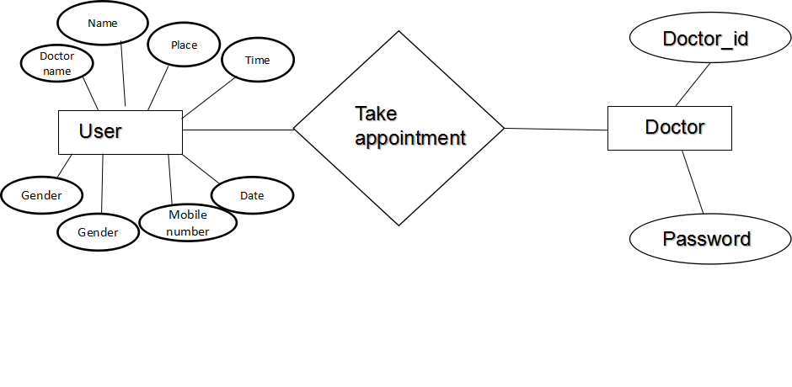

**3.4 USE CASE DIAGRAM:**

A use case diagram at its simplest is a representation of a user's interaction with the system that shows the relationship between the user and the different [use cases](https://en.wikipedia.org/wiki/Use_case) in which the user is involved. A use case diagram can identify the different types of users of a system and the different use cases and will often be accompanied by other types of diagrams as well.

USER DIAGRAM

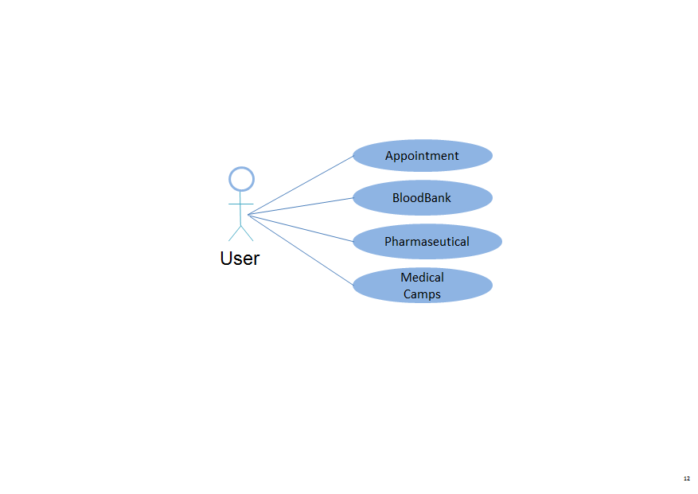

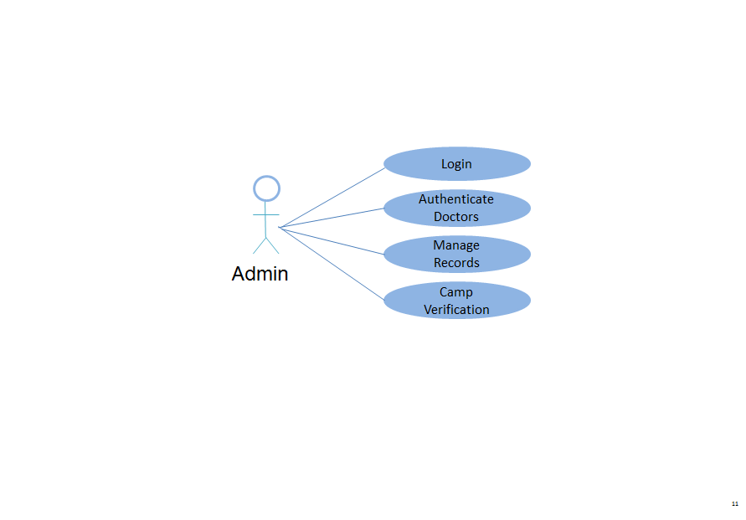ADMIN DIAGRAM:

DOCTOR DIAGRAM:

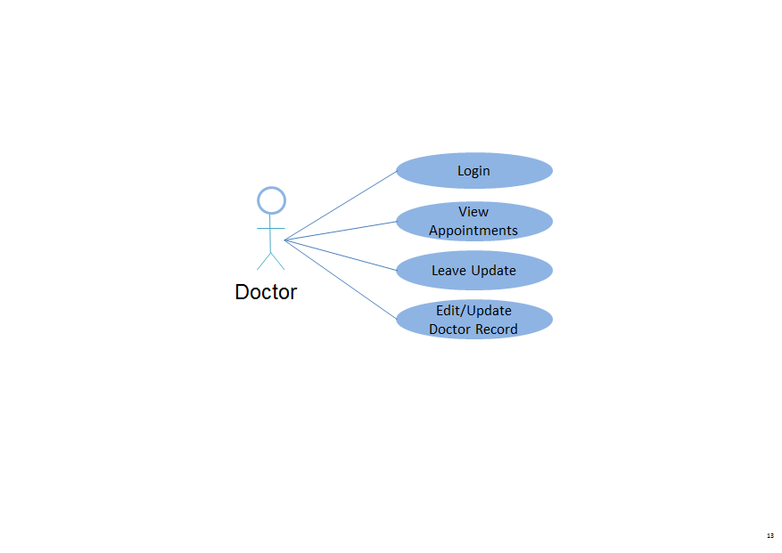

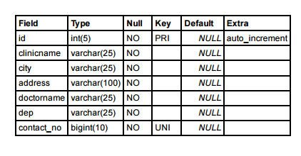**3.6.DATA DICTIONARY**

CLINIC TABLE

DOCTOR_LOG TABLE

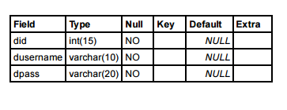

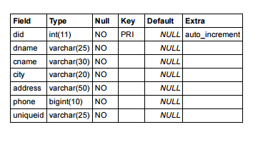DOCTOR TABLE

LIST DONOR

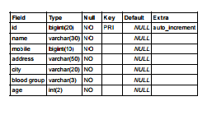

MED CAMPS TABLE

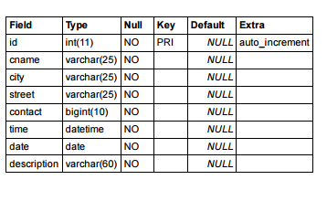

PATIENTS TABLE

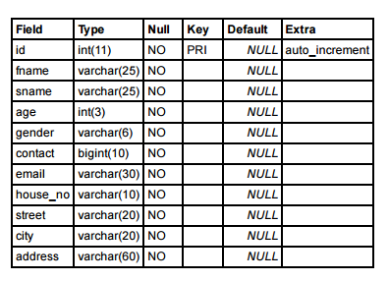

**3.7 GANTT CHART**

A Gantt chart is a graphical depiction of a project schedule. A Gantt chart is a type of bar chart that shows the start and finish dates of several elements of a project that include resources, milestones, tasks and dependencies.

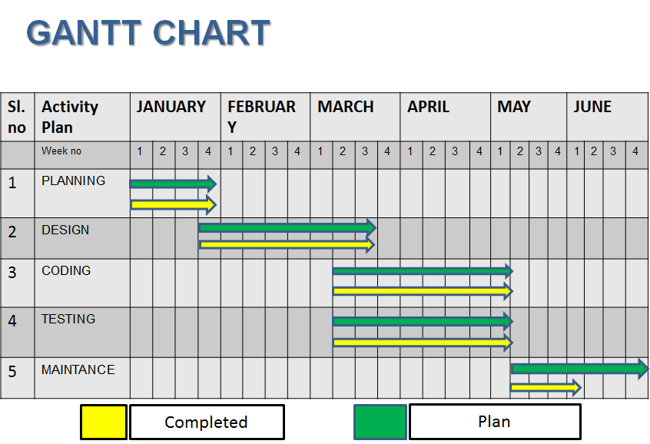

**4. SNAPSHOTS**

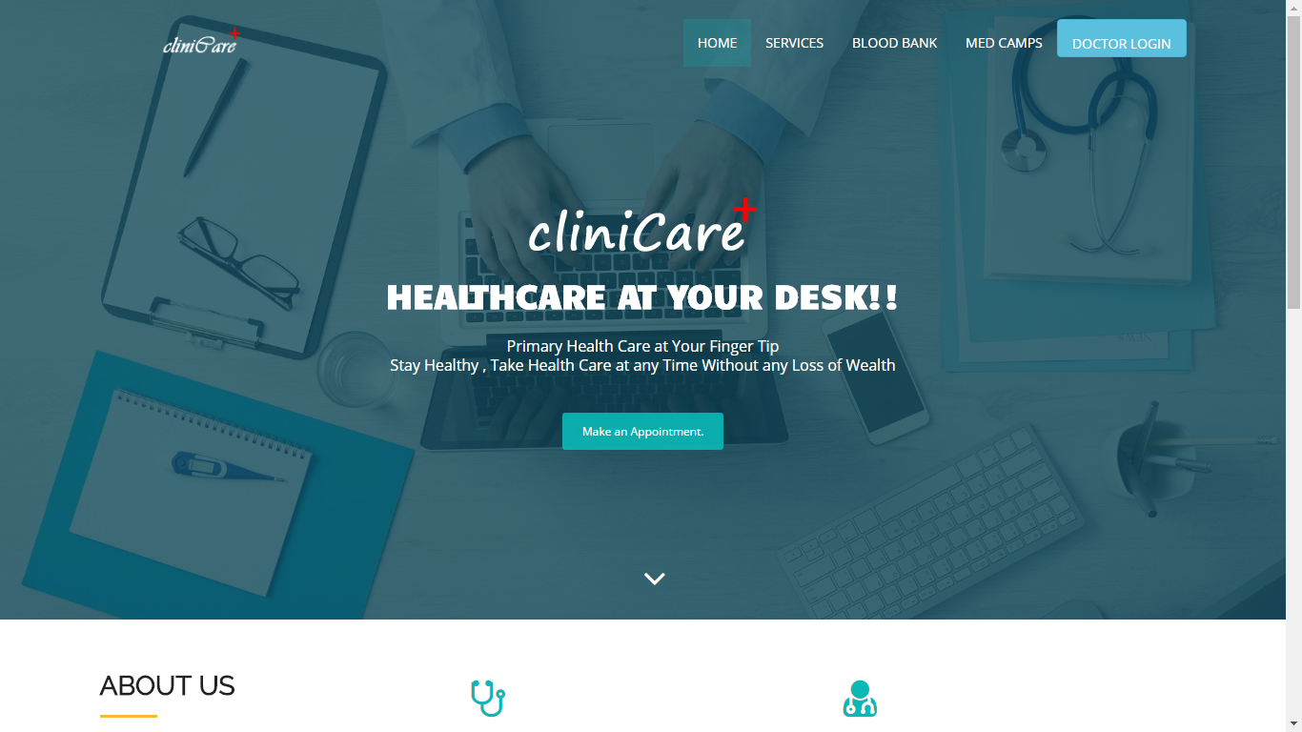**HOME PAGE**

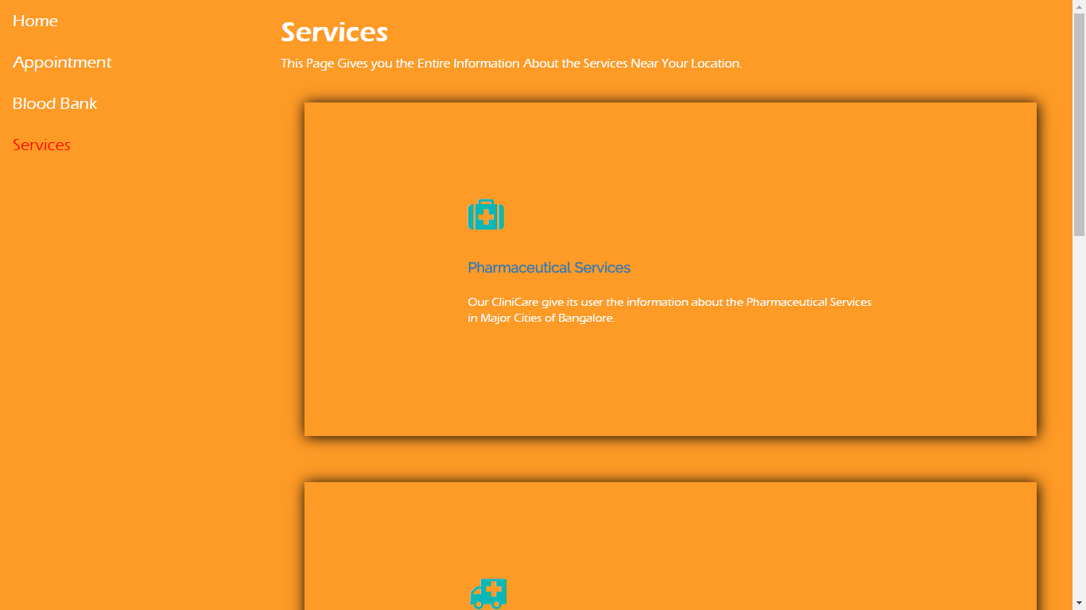**SERVICES PAGE**

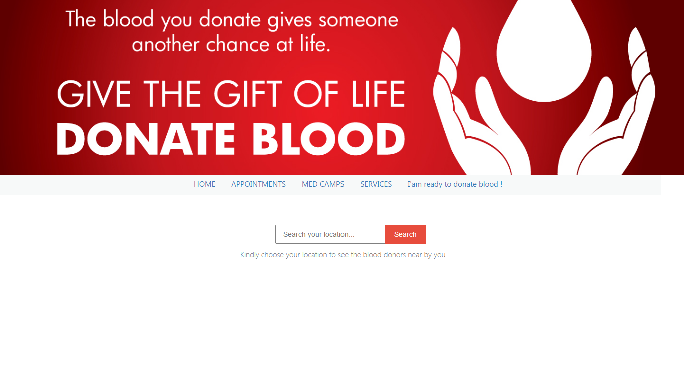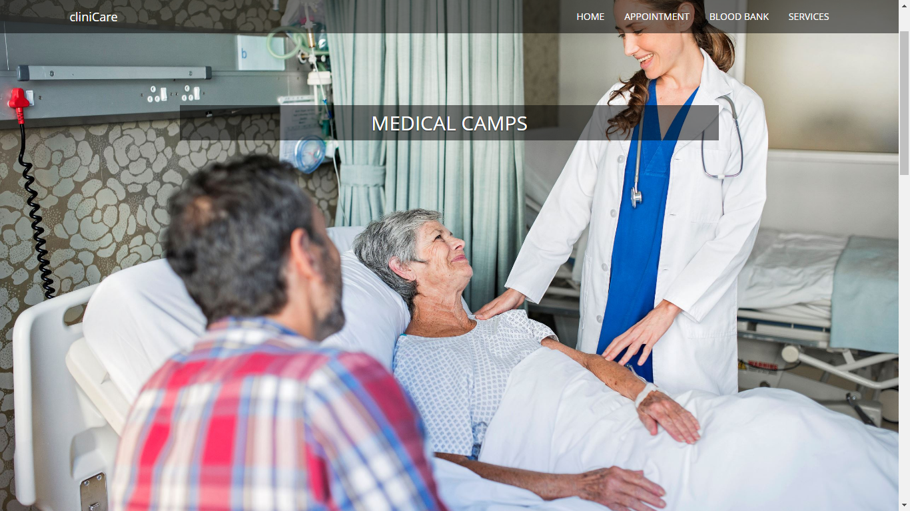**BLOOD BANK PAGE**

**MEDICAL CAMPS PAGE**

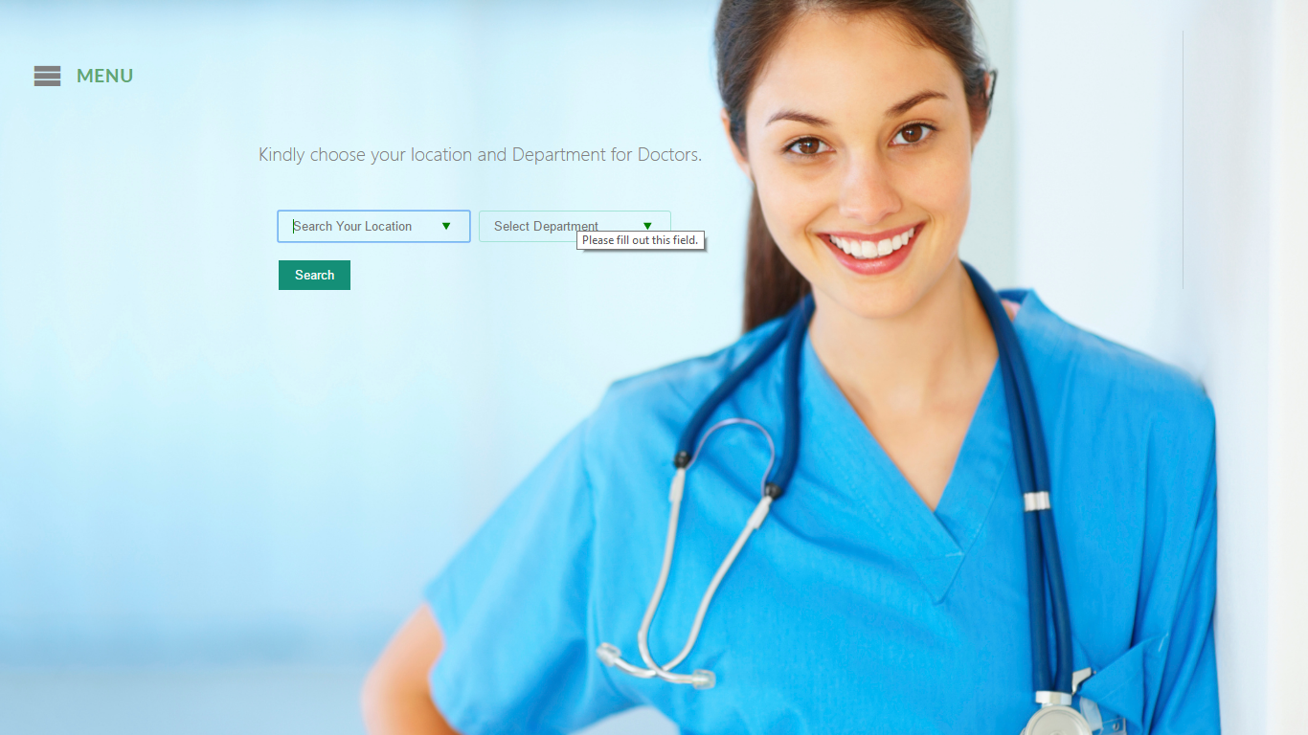**APPOINTMENT PAGE**



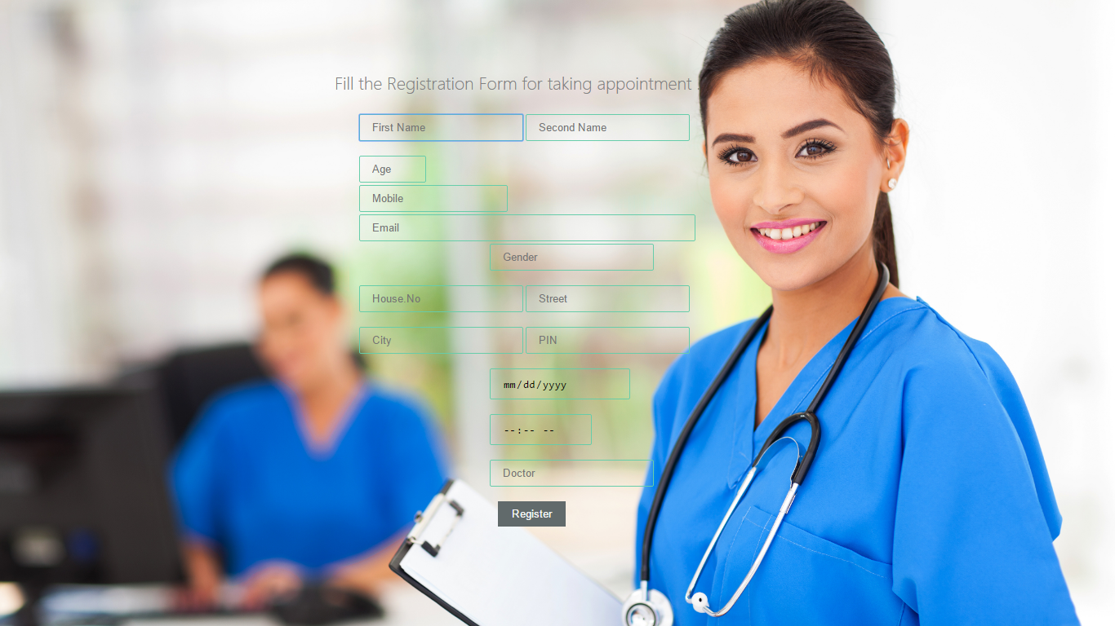**APPOINTMENT REGISTRATION PAGE**

**PAYMENT PAGE**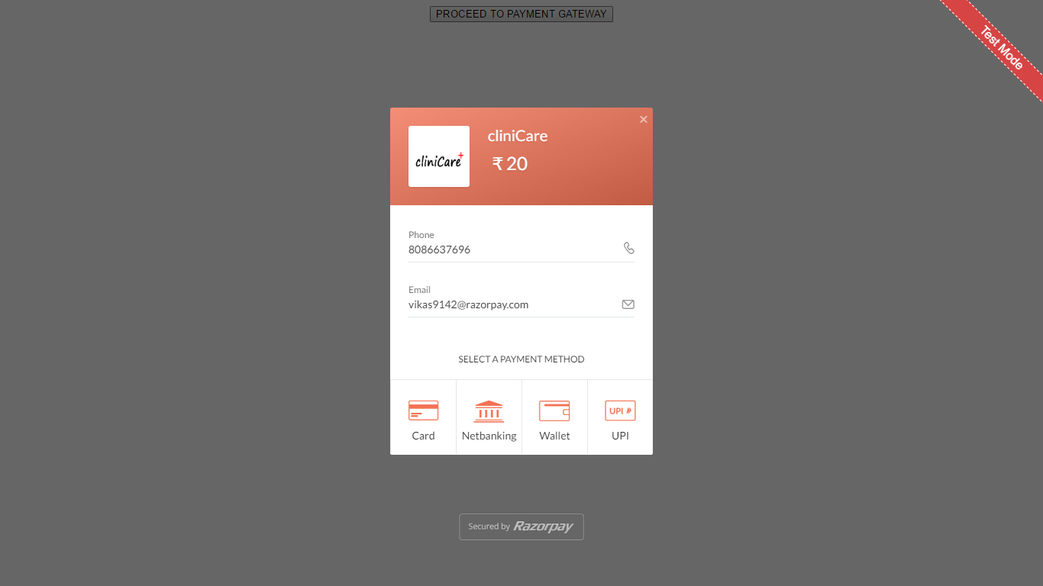

**SALUTATION PAGE**

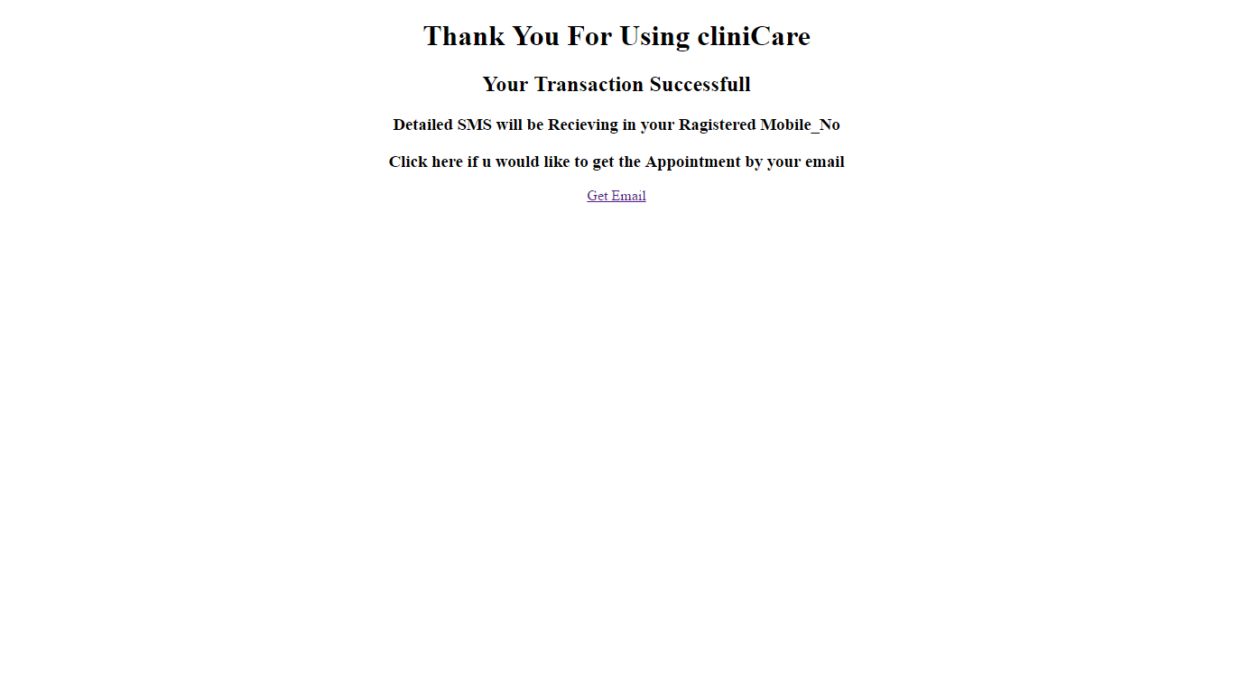

**5.SOURCE CODE**

1. Main Web Pages

**Clinicare_Home.jsp**

<%@page contentType="text/html" pageEncoding="UTF-8"%>

<!DOCTYPE html>

<html lang="en">

<head>

<meta charset="utf-8">

<meta name="viewport" content="width=device- width, initialscale=1">

<title>cliniCare</title>

<link rel="stylesheet" type="text/css" href="<https://fonts.googleapis.com/css>?family=Open+Sans|Raleway|Candal">

<link rel="stylesheet" type="text/css" href="bootstrap/css/font-awesome.min.css">

<link rel="stylesheet" type="text/css" href="bootstrap/css/bootstrap.min_1.css">

<link rel="stylesheet" type="text/css" href="bootstrap/css/style_1.css">

</head>

<style>

#dbtn{ height:40px;height-top:10px;}

#banner{

background: url('img/bg-banner.jpg') no- repeat fixed;

background-size: cover;

min-height: 650px;

position: relative;

}

</style>

<body id="myPage" data-spy="scroll" data-target=".navbar" data-offset="60">

<section id="banner" class="banner">

<div class="bg-color">

<nav class="navbar-default navbar-fixed-top">

<div class="container">

<div class="col-md-12">

<div class="navbar-header">

<button type="button" class="navbar-toggle" data-toggle="collapse" data-target="#myNavbar">

<span class="icon-bar"></span>

<span class="icon-bar"></span>

<span class="icon-bar"></span>

</button>

<a class="navbar-brand" href="#"><img src="img/clini2.png" class="img-responsive" style="width: 140px; margin-top: -16px;"></a>

</div>

<div class="collapse navbar-collapse navbar-right" id="myNavbar">

<ul class="nav navbar-nav">

<li class="active">

<a href="#banner">Home</a>

</li>

<li class="">

<a href="services.jsp">Services</a>

</li>

<li class="">

<a href="bbank.jsp">Blood Bank</a>

</li>

<li class="">

<a href="medcamps.jsp">Med Camps</a>

</li>

<li class="">

<a href="Login.jsp" class="btn btn-info" role="button" id="dbtn">DOCTOR LOGIN</a>

</li>

</ul>

</div>

</div>

</div>

</nav>

<div class="container">

<div class="row">

<div class="banner-info">

<div class="banner-logo text-center">

<img src="img/clini.png" class="img-responsive">

</div>

<div class="banner-text text-center">

<h1 class="white">Healthcare at your desk!!</h1>

<p>Primary Health Care at Your Finger Tip<br>Stay Healthy , Take Health Care at any Time Without any Loss of Wealth </p>

<a href="appointment.jsp" class="btn btn-appo">Make an Appointment.</a>

</div>

<div class="overlay-detail text-center">

<a href="#service"><i class="fa fa-angle-down"></i></a>

</div>

</div>

</div>

</div>

</div>

</section>

<!--/ banner-->

<section id="service" class="section-padding">

<div class="container">

<div class="row">

<div class="col-md-4 col-sm-4">

<h2 class="ser-title">About Us</h2>

<hr class="botm-line">

<p>There are some emergency situations where

people may need the Medical Assistance in the city.Our CLINICARE is a best solution for such people in Bangalore.The CLINICARE is an Online Medical Assistance where the peoplecan get information about the Medical Supports near them.</p>

</div>

<div class="col-md-4 col-sm-4">

<div class="service-info">

<div class="icon">

<i class="fa fa-stethoscope"></i>

</div>

<div class="icon-info">

<h4>24 Hour Support</h4>

<p>Our cliniCare give its user 24 hours access for any facilities within the clinicare.</p>

</div>

</div>

<div class="service-info">

<div class="icon">

<i class="fa fa-ambulance"></i>

</div>

<div class="icon-info">

<h4>Emergency Services</h4>

<p>cliniCare provide all emergency services for the user where they can get the information of 24 hour services in Cities.</p>

</div>

</div>

</div>

<div class="col-md-4 col-sm-4">

<div class="service-info">

<div class="icon">

<i class="fa fa-user-md"></i>

</div>

<div class="icon-info">

<h4>Medical Appointments</h4>

<p>You can search and take appointment for the Doctors available in your location. </p>

</div>

</div>

<div class="service-info">

<div class="icon">

<i class="fa fa-medkit"></i>

</div>

<div class="icon-info">

<h4>Blood Bank</h4>

<p>cliniCare provides you a facility for the blood bank where we will provide you with the blood donors in your location.</p>

</div>

</div>

</div>

</div>

</div>

</section>

<section id="about" class="section-padding">

<div class="container">

<div class="row">

<div class="col-md-3 col-sm-4 col-xs-12">

<div class="section-title">

<h2 class="head-title lg-line">

CliniCare<br>Ultimate Dream</h2>

<hr class="botm-line">

<p class="sec-para">The Dream of Clinicare is to help the people who are new to the city and meet with an emergency where they have no idea of the medical services in that location</p>

<a href="" style="color: #0cb8b6; padding- top:10px;">Know more..</a>

</div>

</div>

<div class="col-md-9 col-sm-8 col-xs-12">

<div style="visibility: visible;" class="col-sm-9 more-features-box">

<div class="more-features-box-text">

<div class="more-features-box-text-icon">

<i class="fa fa-angle-right" aria-hidden="true">

</i>

</div>

<div class="more-features-box-text-description">

<h3>It's something important you want to know.</h3>

<p>Regular Exercising and a Small Walk after Dinner can help you Build a Stronger Stamina and a Healthy Body</p>

</div>

</div>

<div class="more-features-box-text">

<div class="more-features-box-text-icon">

<i class="fa fa-angle-right" aria-hidden="true"></i>

</div>

<div class="more-features-box-text-description">

<h3>It's something important you want to know.</h3>

<p>Strawberies have more Vitamin C than in Oranges .</p>

</div>

</div>

</div>

</div>

</div>

</div>

</section>

<!--testimonial-->

<section id="cta-2" class="section-padding">

<div class="container">

<div class="row">

<div class="col-md-2">

</div>

<div class="text-right-md col-md-4 col-sm-4">

<h2 class="section-title white lg-line"> A Few Words<br>About Us</h2>

</div>

<div class="col-md-4 col-sm-5">

Health is Our Wealth..cliniCare secure your wealth through proper primary cares.

<p class="text-right text-primary"><i>--Busy

Bees</i></p>

</div>

</div>

</div>

</section>

<!--footer-->

<footer id="footer">

<div class="footer-line">

<div class="container">

<div class="row">

<div class="col-md-12 text-center">

© Copyright cliniCare . All Rights Reserved

<div class="credits">

Designed by <a href="#">BUSY BEES</a>

</div>

</div>

</div>

</div>

</div>

</footer>

<script src="bootstrap/js/jquery.min_1.js"></script>

<script src="bootstrap/js/jquery.easing.min.js">

</script>

<script src="bootstrap/js/bootstrap.min_1.js">

</script>

<script src="bootstrap/js/custom.js"></script>

<script src="contactform/contactform.js"></script>

</body>

</html>

**2.Blood Bank Page**

bbank.jsp

<[%@page](mailto:%25@page) contentType="text/html" pageEncoding="UTF-8"%>

<!DOCTYPE html>

<html>

<head>

<meta http-equiv="Content-Type" content="text/html; charset=UTF-8">

<link href="bootstrap/css/bootstrap.min.css" rel="stylesheet">

<link href="styles.css" rel="stylesheet">

<title>blood bank</title>

</head>

<style>

#u{

background-color:#F7F9F9;font-family: Microsoft New Tai Lue;

position:fixed;font-size: 15px;}

.fm{

position: absolute;

top:450px;

left:550px;

}

.search {

padding:8px 15px;

background:transparent;

width:250px;

border:1px solid grey;

border-radius: 2px;

}

.button {

position:relative;

padding:6px 15px;

left:-35px;

border:3px solid #E74C3C;

background-color:#e74c3c;

color:#fafafa

}

#txt{

color:grey;

font-family: Microsoft YaHei Light;position: fixed;

left:480px;

top:500px;

}

body{

background-color: white;

}

</style>

<body>

<div id="top"

style="background-image:url('images/02.jpg'); height:350px;">

</div>

<div id="navigation">

<ul class="nav nav-pills navbar-inverse" id="u">

<li style="width:370px;height:40px;"></li>

<li><a href="home.jsp">HOME</a></li>

<li><ahref="appointment.jsp">APPOINTMENTS</a>

</li>

<li><a href="medcamps.jsp">MED CAMPS</a></li>

<li><a href="services.jsp">SERVICES</a></li>

<li style="width:300px;height:0px;"></li>

<li><a href="dblood.jsp">I'am ready to donate blood !</a></li>

</ul>

<datalist id="locs">

<option value="Electronic city">

<option value="BTM Layout">

<option value="Madiwala">

<option value="Brigade">

<option value="UB City">

<option value="Majestic">

<option value="Koramangala">

<option value="Hebbal">

</datalist>

<div id="txt">Kindly choose your location to see the blood donors near by you.</div>

<form action="vdonor.jsp" method="post" class="fm">

<input class="search" type="text" list="locs" name="user" placeholder="Search your location..." required>

<input class="button" type="submit" value="Search">

</form>

</body>

</html>

**3.View Donors Page**

vdonor.jsp

<%@page import="java.sql.ResultSet"%>

<%@page import="java.sql.PreparedStatement"%>

<%@page import="java.sql.DriverManager"%>

<%@page import="java.sql.Connection"%>

<%@page import="java.io.InputStreamReader"%>

<%@page contentType="text/html" pageEncoding="UTF-8"%>

<%

Class.forName("com.mysql.jdbc.Driver");

Connection con = DriverManager.getConnection("jdbc:mysql://localhost:3306/clinicare", "root", "");

String loc=request.getParameter("user");

String qry="Select * from ldonors where city=?";

PreparedStatement ps=con.prepareStatement(qry);

ps.setString(1,loc);

ResultSet rs=ps.executeQuery();

// while(rs.next())

/* {

out.println(rs.getString(2)+" "+rs.getBigDecimal(3));

out.println("<br>");

}*

//out.println(loc);

%>

<!DOCTYPE html>

<html>

<head>

<meta http-equiv="Content-Type" content="text/html; charset=UTF-8">

<title>view donors</title>

</head>

<style>

#l{

color: grey;

font-size: 20px;

font-family:Microsoft YaHei Light;}

</style>

<body>

<br>

<h2><div id="l"> List of Peoples Donating Blood in City<div style="color:red;"><% out.println(loc); %></div></div></h2><br><br><br><br>

<div style="font-size: 15px;font-family:Microsoft YaHei Light;font-weight: bold;">

<%

while(rs.next())

{

out.println(rs.getString(2)+

"&nbsp;&nbsp;&nbsp;:");

out.println(" &nbsp;&nbsp;&nbsp;&nbsp;

&nbsp;&nbsp;&nbsp;&nbsp;");

out.println(rs.getBigDecimal(3)+" &nbsp;&nbsp;&nbsp;"+rs.getString(6)

+"<hr>");

out.println("<br>");

}

%>

</div>

</body>

</html>

**4.Services Page**

Services.jsp

<%@page contentType="text/html" pageEncoding="UTF-8"%>

<!DOCTYPE html>

<html>

<head>

<title>Services</title>

<link rel="stylesheet" type="text/css" href="https://fonts.googleapis.com/css?family=Open+Sans|Raleway|Candal">

<link rel="stylesheet" type="text/css" href="bootstrap/css/font-awesome.min.css">

<link rel="stylesheet" type="text/css" href="bootstrap/css/bootstrap.min_1.css">

<link rel="stylesheet" type="text/css" href="bootstrap/css/style_1.css">

<link rel="stylesheet" type="text/css" href="bootstrap/css/services.css">

<script>

(function(i,s,o,g,r,a,m){i['GoogleAnalyticsObject']=r;i[r]=i[r]||function(){

(i[r].q=i[r].q||[]).push(arguments)},i[r].l=1*new Date();a=s.createElement(o),

m=s.getElementsByTagName(o)[0];a.async=1;a.src=g;m.parentNode.insertBefore(a,m)

})(window,document,'script','https://www.google-analytics.com/analytics.js','ga');

ga('create', 'UA-97899853-1', 'auto');

ga('send', 'pageview');

</script>

</head>

<body>

<ul>

<li><a href="Clinicare_Home.jsp">Home</a></li>

<li><a href="appointment.jsp">Appointment</a></li>

<li><a href="bbank.jsp">Blood Bank</a></li>

<li><a class="active" href="services.jsp">Services</a></li>

</ul>

<div class="page">

<h1 style="color:white; font-family: Eras ITC;">Services</h1>

<p>This Page Gives you the Entire Information About the Services Near Your Location.</p>

<div class="blocks">

<div class="service-info">

<div class="icon">

<i class="fa fa-medkit"></i>

</div>

<div class="icon-info">

<h4><a href="service_pharmacy.jsp">Pharmaceutical Services</a></h4>

<p>Our CliniCare give its user the information about the Pharmaceutical Services in Major Cities of Bangalore.</p>

</div>

</div>

</div>

<div class="blocks">

<div class="service-info">

<div class="icon">

<i class="fa fa-ambulance"></i>

</div>

<div class="icon-info">

<h4><a href="services_Ambulance.jsp">Ambulance Service</a></h4>

<p>Clinicare provide all the Ambulance Service information in the Major Cities of Bangalore.</p>

</div>

</div>

</div>

<div class="blocks">

<div class="service-info">

<div class="icon">

<i class="fa fa-user-md"></i>

</div>

<div class="icon-info">

<h4><a href="services_laboratory.jsp">Laboratory Service</a></h4>

<p>Clinicare provides the information of the Major Laboratory Services of Bangalore Cities.</p>

</div>

</div>

</div>

<div class="blocks">

<div class="service-info">

<div class="icon">

<i class="fa fa-stethoscope"></i>

</div>

<div class="icon-info">

<h4>Blood Bank</h4>

<p>cliniCare provides you a facility for the blood bank where we will provide you with the blood donors in your location.</p>

</div>

</div>

</div>

</div>

</body>

</html>

**5.Medical Camps Page**

Medcamp.jsp

<%@page import="java.text.SimpleDateFormat"%>

<%@page import="java.sql.ResultSet"%>

<%@page import="java.sql.PreparedStatement"%>

<%@page import="java.sql.DriverManager"%>

<%@page import="java.sql.Connection"%>

<%@ page import="java.io.*,java.util.*, javax.servlet.*" %>

<%

SimpleDateFormat sdf = new SimpleDateFormat("yyyy-MM-dd");

String datenow=sdf.format(new Date());

out.println(datenow);

Class.forName("com.mysql.jdbc.Driver");

Connection con = DriverManager.getConnection("jdbc:mysql://localhost:3306/clinicare", "root", "");

String qry="Select * from medcamps";

String qry2="delete from medcamps where date=?";

PreparedStatement ps2=con.prepareStatement(qry2);

ps2.setString(1,datenow);

ps2.executeUpdate();

PreparedStatement ps=con.prepareStatement(qry);

ResultSet rs=ps.executeQuery();

%>

<!DOCTYPE html>

<html>

<head>

<meta charset="utf-8" />

<meta name="viewport" content="width=device-width, initial-scale=1, maximum-scale=1" />

<meta name="description" content="" />

<meta name="author" content="" />

<title>Medical Camps</title>

<link href="assets/css/bootstrap.css" rel="stylesheet" />

<link href="assets/css/font-awesome.min.css" rel="stylesheet" />

<link href="assets/css/style.css" rel="stylesheet" />

</head>

<style>

#m{margin-bottom: 550px;}

</style>

<body >

<div class="navbar navbar-inverse navbar-fixed-top" style="background:rgba(0,0,0,0.5);border:none;">

<div class="container">

<div class="navbar-header">

<button type="button" class="navbar-toggle" data-toggle="collapse" data-target=".navbar-collapse">

<span class="icon-bar"></span>

<span class="icon-bar"></span>

<span class="icon-bar"></span>

</button>

<a class="navbar-brand" href="#">cliniCare</a>

</div>

<div class="navbar-collapse collapse">

<ul class="nav navbar-nav navbar-right">

<li><a href="Clinicare_Home.jsp">HOME</a></li>

<li><a href="appointment.jsp">APPOINTMENT</a></li>

<li><a href="bbank.jsp">BLOOD BANK</a></li>

<li><a href="services.jsp">SERVICES</a></li>

</ul>

</div>

</div>

</div>

<!--/.NAVBAR END-->

<!-- <section id="home" class="text-center">-->

<div id="carousel-example" class="carousel slide" data-ride="carousel">

<div class="carousel-inner">

<div class="item active">

<img src="img/medcamp4.jpg" alt="" />

<div class="carousel-caption" >

<h2 class="back-light" id="m">MEDICAL CAMPS</h2>

</div>

</div>

</div>

</div>

<section id="intro">

<div class="container">

<div class="row text-center" >

<div class="col-md-12">

<div class="row text-center pad-row ">

<% while(rs.next())

{

%>

<div class="col-md-4 col-sm-4 ">

<h3><strong><%= rs.getString(2) %></strong> </h3>

<p>Place : <%= rs.getString(3) %></p>

<p>Street : <%= rs.getString(4) %></p>

<p>on : <%= rs.getString(7) %> at : <%= rs.getString(6)%></p>

<p>

About Camp : <%= rs.getString(8)%> </p>

<p> Ph : <%= rs.getString(5)%></p>

</div>

<% } %>

<!-- <div class="col-md-4 col-sm-4 ">

<img class="img-circle" src="assets/img/tea2.jpg" alt="" />

<h3><strong>Blood Donation Camp</strong> </h3>

<p>

St.Johns hospital is conducting a blood donation camp

in govt. school in Anekkal Taluk. Those who are intrested in

charity services you can be the part

Ph : 2280547

</p>

</div> -->

</div>

</div>

</div>

</div>

</section>

<!--/.INTRO END-->

<section id="offer" >

<div class="container">

<div class="row alert alert-info" >

<div class="col-md-8 col-sm-8">

<h1> Are you a social worker ? you can inform about medical camps </h1>

</div>

<div class="col-md-4 col-sm-4" style="padding-top: 15px;">

<a href="medcampinfo.jsp" class=" btn btn-primary btn-lg">Inform Here</a>

</div>

</div>

</div>

</section>

<section class="note-sec" >

<div class="container">

<div class="row text-center pad-row" >

<div class="col-md-8 col-md-offset-2 col-sm-8 col-sm-offset-2 ">

<i class="fa fa-quote-left fa-3x"></i>

<p>Majority of the people living in remote villages are daily wage laborers,

who earn very meager income.

They don't go hospital or get a health checkup even when they are sick. Because,

their little income won't be sufficient to afford to the costs

of getting a good health checkup or buying

the medicines the doctor has prescribed for them.

Hence, many people die each year even though their sickness was easily curable.</p>

</div>

</div>

</div>

</section>

<section id="footer-sec" >

<div class="container">

<div class="row pad-bottom" >

<div class="col-md-4">

<h4> <strong>ABOUT CLINICARE</strong> </h4>

<p>

Clinicare is a social service website that try to gives solution about major medical issues

in your city in Bengaluru. Those are really want to help others they also can be part of us with

this website .

</p>

<a href="#" >read more</a>

</div>

<div class="col-md-4">

<h4> <strong>SOCIAL LINKS</strong> </h4>

<p>

<a href="#"><i class="fa fa-facebook-square fa-3x" ></i></a>

<a href="#"><i class="fa fa-twitter-square fa-3x" ></i></a>

<a href="#"><i class="fa fa-linkedin-square fa-3x" ></i></a>

<a href="#"><i class="fa fa-google-plus-square fa-3x" ></i></a>

</p>

</div>

<div class="col-md-4">

<a href="#" class="btn btn-primary" >SEND QUERY</a>

</div>

</div>

</div>

</section>

<!--/.FOOTER END-->

<!-- JAVASCRIPT FILES PLACED AT THE BOTTOM TO REDUCE THE LOADING TIME -->

<!-- CORE JQUERY -->

<script src="assets/plugins/jquery-1.10.2.js"></script>

<!-- BOOTSTRAP SCRIPTS -->

<script src="assets/plugins/bootstrap.js"></script>

<!-- CUSTOM SCRIPTS -->

<script src="assets/js/custom.js"></script>

</body>

</html>

**5.Appointment Page**

Appointment.jsp

<%@page contentType="text/html" pageEncoding="UTF-8"%>

<!DOCTYPE html>

<html>

<head>

<meta http-equiv="Content-Type" content="text/html; charset=UTF-8">

<link href="styles.css" rel="stylesheet">

<link rel="shortcut icon" href="bootstrap/fonts/favicon.ico">

<link rel="stylesheet" type="text/css" href="bootstrap/css/default.css" />

<link rel="stylesheet" type="text/css" href="bootstrap/css/component.css" />

<script src="bootstrap/js/modernizr.custom.js"></script>

<title>appointment</title>

</head>

<style>

body{background-image: url('images/reg2.jpg');background-size: 100%;}

.fm{position: absolute;top:220px;left:290px;}

.search {padding:8px 15px;background:transparent;

border:1px solid #A3E4D7;color:green;border-radius: 3px}

.button {position:relative; padding:6px 15px;

border:2px solid #148F77;background-color:#148F77;color:#fafafa;left:1px;}

#txt{color:grey;font-family: Microsoft YaHei Light;position: fixed;left:270px;top:150px;font-size: 18px;}

</style>

<body>

<!-- <div id="top" style="background-image: url('images/reg.jpg');height:623px;background-position: right;"></div>-->

<div class="container">

<div class="main">

<div class="side">

<nav class="dr-menu">

<div class="dr-trigger"><span class="dr-icon dr-icon-menu"></span><a class="dr-label">Menu</a></div>

<ul>

<li><a class="dr-icon dr-icon-heart" href="Clinicare_Home.jsp">Home</a></li>

<li><a class="dr-icon dr-icon-camera" href="bbank.jsp">Blood Bank</a></li>

<li><a class="dr-icon dr-icon-bullhorn" href="#">Med Camps</a></li>

<li><a class="dr-icon dr-icon-download" href="#">Pharmaceutical</a></li>

</ul>

</nav>

</div>

</div>

</div>

<script src="bootstrap/js/ytmenu.js"></script>

<datalist id="locs">

<option value="Electronic city">

<option value="BTM Layout">

<option value="Madiwala">

<option value="Brigade">

<option value="UB City">

<option value="Majestic">

<option value="Koramangala">

<option value="Hebbal">

</datalist>

<datalist id="dept">

<option value="General">

<option value="Dental">

<option value="ENT">

<option value="Pediatric">

<option value="Cardiologist">

<option value="Psyciatrist">

<option value="Gianacologist">

</datalist>

<div id="txt">Kindly choose your location and Department for Doctors.</div>

<form class="fm" action="appoinment.jsp" method="post">

<input class="search" type="text" list="locs" name="lc" placeholder="Search Your Location" required>&nbsp;&nbsp;

<input class="search" type="text" list="dept" name="dp" placeholder="Select Department" required><br><br>

<input class="button" type="submit" value="Search">

</form>

<form class="fm" action="appointment.jsp" method="post">

<%

String lc=request.getParameter("lc");

String dp=request.getParameter("dp");

%>

<input class="search" type="text" name="lc" list="locs" value="<%=lc %>" placeholder="Search Your Location" required>&nbsp;&nbsp;

<input class="search" type="text" name="dp" list="dept" value="<%=dp %>" placeholder="Select Department" required><br><br>

<br><input class="button" type="submit" value="Search for Doctors">

</form>

<form class="fm1" action="appo_reg.jsp" method="post">

<%

Connection con = null;

PreparedStatement ps = null;

try

{

Class.forName("com.mysql.jdbc.Driver");

con = DriverManager.getConnection("jdbc:mysql://localhost:3306/clinicare", "root", "");

String qry="Select * from clinics where city=? and dep=?";

ps=con.prepareStatement(qry);

ps.setString(1,lc);ps.setString(2, dp);

ResultSet rs=ps.executeQuery();

%>

<p style="color:grey;font-family: Microsoft YaHei Light;font-size: 16px;">Select Doctor Name :&nbsp;

<select class="search" style="height:32px;">

<option>--None--</option>

<%

while(rs.next())

{

String dctrname = rs.getString("doctorname");

%>

<option value="<%=dctrname %>"><%=dctrname %></option>

<%

}

%>

</select>

</p>

<%

}

catch(SQLException sqe)

{

out.println(sqe);

}

%>

<br><input class="button" type="submit" value="Register">

</form>

</body>

</html>

appo_reg.jsp

<%@page contentType="text/html" pageEncoding="UTF-8"%>

<!DOCTYPE html>

<html>

<head>

<meta http-equiv="Content-Type" content="text/html; charset=UTF-8">

<link href="styles.css" rel="stylesheet">

<title>registration</title>

</head>

<style>

body{background-image: url('images/reg.jpg');background-size: 100%;}

.d{border-radius: 5px;background-color: #D1F2EB;padding:220px;width: 60px;margin-top: 50px;}

.fm{position: absolute;top:140px;left:600px}

.search {padding:8px 15px;background:transparent;

border:1px solid mediumaquamarine;border-radius: 2px;}

.button {position:relative; padding:6px 15px;left:10px;

border:2px solid #616A6B;background-color:#616A6B;color:whitesmoke;}

#txt{color:grey;font-family:Microsoft YaHei Light;position:absolute;left:410px;top:90px;font-size: 20px;}

#txtfld{position:absolute;left:-160px;}

#txtfld1{position:absolute;left:-160px;}

</style>

<body bgcolor="#1ABC9C">

<div id="txt">Fill the Registration Form for taking appointment .</div>

<div>

<form class="fm" action="reg_validation.jsp" method="post">

<input class="search" type="text" name="appo_fname" placeholder="First Name" required id="txtfld1">&nbsp;&nbsp;&nbsp;&nbsp;&nbsp;&nbsp;&nbsp;&nbsp;&nbsp;&nbsp;

<input class="search" type="text" name="appo_sname" placeholder="Second Name" required><br><br>

<input class="search" type="text" name="appo_age" placeholder="Age" required id="txtfld" style="width:50px;"><br><br>

<input class="search" type="text" name="appo_mob" placeholder="Mobile " required id="txtfld" style="width:150px;"><br><br>

<input class="search" type="email" name="appo_mail" placeholder="Email" required id="txtfld" style="width:380px;"><br><br>

<input class="search" type="text" name="gender" placeholder="Gender" required><br><br>

<input class="search" type="text" name="appo_house" placeholder="House.No" required id="txtfld">&nbsp;&nbsp;&nbsp;&nbsp;&nbsp;&nbsp;&nbsp;&nbsp;&nbsp;&nbsp;

<input class="search" type="text" name="appo_street" placeholder="Street" required><br><br>

<input class="search" type="text" name="appo_city" placeholder="City" required id="txtfld1">&nbsp;&nbsp;&nbsp;&nbsp;&nbsp;&nbsp;&nbsp;&nbsp;&nbsp;&nbsp;

<input class="search" type="text" name="appo_pin" placeholder="PIN" required><br><br>

<input class="search" type="date" name="appo_date" placeholder="Appointment Date" required><br><br>

<input class="search" type="time" name="appo_time" placeholder="Appointment time" required><br><br>

<input class="search" type="text" name="appo_doc" placeholder="Doctor" required><br><br>

<input class="button" type="submit" value="Register">

</form>

</div>

</body>

</html>

reg_validation.jsp

<%--

Document : reg_validation

Created on : Apr 26, 2017, 10:21:50 PM

Author : USER

--%>

<%@page import="java.sql.*"%>

<%@ page import = "javax.servlet.RequestDispatcher" %>

<%

Class.forName("com.mysql.jdbc.Driver");

Connection con = DriverManager.getConnection("jdbc:mysql://localhost:3306/clinicare", "root", "");

String fname=request.getParameter("appo_fname");

String sname=request.getParameter("appo_sname");

String age=request.getParameter("appo_age");

String mob=request.getParameter("appo_mob");

String mail=request.getParameter("appo_mail");

String house=request.getParameter("appo_house");

String street=request.getParameter("appo_street");

String city=request.getParameter("appo_city");

String pin=request.getParameter("appo_pin");

String gender=request.getParameter("gender");

String date=request.getParameter("appo_date");

String time=request.getParameter("appo_time");

String doctor=request.getParameter("appo_doc");

String qry="INSERT INTO `regdata`(`fname`, `lname`, `age`, `mobile`, `email`, `houseno`, `street`, `city`, `pin`,`gender`,`Appointment_Date`,`Appointment_Time`,`Doctor`) VALUES (?,?,?,?,?,?,?,?,?,?,?,?,?)";

PreparedStatement ps=con.prepareStatement(qry);

ps.setString(1,fname);ps.setString(2, sname);ps.setString(3, age);

ps.setString(4, mob);ps.setString(5, mail);ps.setString(6, house);

ps.setString(7, street);ps.setString(8, city);ps.setString(9, pin);

ps.setString(10, gender);ps.setString(11, date);ps.setString(12, time);

ps.setString(13, doctor);

ps.executeUpdate();

String message = "HI Welcome";

RequestDispatcher rd = request.getRequestDispatcher("Payment.jsp");

request.setAttribute("msg",message);

rd.forward(request, response);

%>

**6.TEST**

Table of Contents:

1. Test Plan Identifier

2. Introduction

2.1 Objectives

2.2 Scope

2.3 References

3. Test Items

4. Approach

4.1 Unit Testing

4.2 Integration Testing

4.3 System Testing

4.4 Performance Testing

4.5 Regression Testing

4.6 Manual Testing

5. Item Pass/Fail Criteria

6. Suspension Criteria or Resumption Requirements

6.1 Suspension Criteria

6.2 Resumption Requirements

1. Test Plan Identifier

CLINICARE

2. Introduction

The main purpose of preparing this document “Test Plan” is to test the critical use cases and the functionalities that outline the project “CLINICARE”.

The following sections will detail the item that would be tested during the testing process, an overview will present the portions of the software that require testing and a test plan of how these features will be tested. The document will address the objectives, the scope of the document and the different testing approaches used.

2.1 Objectives

The following system test plan for the “CLINICARE” will support the following objectives:

* Identify the features of the project that need to be tested.
* Define the testing approaches that will be used during testing.
* Define the pass/fail criteria for each item that would be tested.
* Define the suspension criteria and resumption technique for the same.

2.2 Scope

The document “Test Plan” will cover all the items that need to be tested and all the test approaches involved. It will also define the pass/fail criteria for each of the item being tested.

3. Test Items

The following items will be tested during the test process:

* Registration
* Login
* Forgot password
* Change password

4. Approach

The application will be tested with all the possible inputs and would be checked for all the possible outputs. A list of test cases will be prepared for testing the application. The tester would perform black box testing that is the functional/operational testing on all the items that need to be tested. Each item would contain one or more test cases, the types of testing and critical use-cases acceptance by the system. The tester would give in the inputs to the system, and then verify that the output matches the desired output outline in the document.

4.1 Unit Testing:

In this particular testing, each module is tested alone in an attempt to discover any errors that may be present in code, which means all executable source code is subject to test. The test would include all the classes, and the forms in the code for testing. Particular advantages and disadvantages of unit testing are: Advantage: that the total system is subject to testing and each module will thus be tested. Possible Disadvantage: Because of the system size, it is possible some errors might be missed and not identifies.

4.2 Integration Testing:

The integration testing will consist of combined parts of an application to determine if they function together correctly and to see whether or not the main requirements of the system are achieved. This type of testing is specifically relevant to client-server and distributed systems. Thus all the modules involved in the project will be integrated together and tested accordingly as a whole system.

4.3 System Testing:

The system testing is performed to test the entire system and to see whether all the critical requirements are satisfied or not. The system would be checked with multiple user’s login in at the same time, so the performance is also checked. The test cases used in here, will be a combination of the ones from unit testing and the most important part of testing will be the preservation of data.

4.4 Performance Testing:

Performance of the system depends upon the number of users using the system at a time, and how well the system would be able to respond to the customer’s queries. The present system would be compared to that of already existing ones and the results will be reported.

4.5 Regression Testing

This type of testing means that several iterations of the system test will be done in order to test program modifications made during the system test period. A regression test will be performed on each of the new version of the system to detect any unexpected impact resulting from program modification. The regression test will be done by running all of the tests on the newer version of the system that was originally run on the previous version and then comparing the new results with that of the old ones.

4.6 Manual Testing:

Manual testing is also done so as to find undiscovered or unexpected errors in the system.

5. Item Pass/Fail Criteria:

The test cases executed on “CLINICARE” passes if it meets the specific requirements and if the results match that of the expected outputs. The items is said to fail the system if the results that the test case produces does not match the desired result. Test cases are evaluated independent of one another, having no effects on the evaluation of the other test cases.

6. Suspension Criteria or Resumption Requirements

6.1 Resumption Requirements

The test cases that are not dependent on the bug found will be executed along with fixing the bug, and the testing for the failed test case will resume when the solution for fixing the bug has been found and the bug has been resolved.

6.2 Suspension Criteria

During testing if a test case fails, then testing will be suspended for all the related modules of the test case. A log will be prepared where in the error will be reported along with the description.

7. Test Deliverable

The following documents will be prepared at the end of the testing:

* Test Plan
* Test cases
* Test Log
* Test Summary Report

**TEST CASE**

|  |  |  |  |  |  |
| --- | --- | --- | --- | --- | --- |
| Module: | Doctor Login | | | | |
| Test Objective | To check whether Doctor able to login with their user name and password. | | | | |
| Test case no. | 1 | | | | |
| SI.NO | Test case Objective | Steps to Execute | Input Data | Expected Output | Pass/Fail |
| 1.1 | Checking whether it accepts the valid user name and password . | Enter valid user name and password. | User name=  Vikas9142  Password=  ”********”. | It should navigate to the doctor dashboard page of respective selection. | Pass. |
| 1.2 | Checking whether it accepts the Invalid valid user name and password . | Enter Invalid valid user name and password | User name=  Vikas  Password=  ”********”. | It should validate the given data and display User name or password is incorrect. | Pass. |
| 1.3 | Checking whether it accepts the empty field values. | Click login button. | User name  Password | It should display fields cannot be Blank | Pass. |
| 1.4 | Checking whether the entering password is masking. | Enter user name and password. | User name=  Vikas912  Password=  ”********”. | The password fields are masking the password. | Pass |

**TEST CASE 2**

|  |  |  |  |  |  |
| --- | --- | --- | --- | --- | --- |
| Module: | Add donor | | | | |
| Test Objective | To check whether added donors are updating in view donors. | | | | |
| Test case no. | 2 | | | | |
| SI.NO | Test case Objective | Steps to Execute | Input Data | Expected Output | Pass/Fail |
| 1.1 | Checking whether it accepts the new donors registering . | Enter genuine data. | name=Vikas  age=22  City=Ecity  Gender=Male  Ph=7026823681  Address=phase2  Blood Group=A+ | It should display registered successfully and should be displayed on view donors . | Pass. |
| 1.2 | Checking whether it accepts only phone numbers in Conatct number field. | Enter string in contact field | Ph=”contact” | It should display only phone numbers are accepted. | Fail. |

**TEST CASE 3**

|  |  |  |  |  |  |
| --- | --- | --- | --- | --- | --- |
| Module: | Patients Appointment | | | | |
| Test Objective | To check appointments details are getting after payment. | | | | |
| Test case no. | 3 | | | | |
| SI.NO | Test case Objective | Steps to Execute | Input Data | Expected Output | Pass/Fail |
| 1.1 | Checking whether it accepts valid contact number and email navigates to payment page . | Enter valid phone number and email with details. | Phone no= 7026823681 Email= Vikas9142@gmail.com. | It should navigate to the doctor dashboard page of respective selection. | Pass. |
| 1.2 | Checking whether it accepts In valid contact number and email . | Enter Invalid valid phone and email | Phone no= phonenogiving Email= Vikas@gmail.com. | It should display invalid phone or email. | Fail. |
| 1.3 | Checking whether it sending appointment details after payment. | Make payment and click OK. |  | It should send appointment details through sms and email | Pass. |

**BUG REPORT**

|  |  |  |  |
| --- | --- | --- | --- |
| **Bug ID** | 1 | | |
| **Originator** | VISHNU KN | Email: | Phone: |
| **Submit Date** | 09-06-2017 | | |
| **Summary** | Contact field accepts invalid credential | | |
| **Severity** | [normal] | | |
| **Product** | Website | | |
| **Component** | Not applicable | | |
| **Version** | 1.5 | | |
| **Platform** | [PC ] | | |
| **OS** | [Windows] | | |
| **Browser** | [Google Chrome] | | |
| **URL** | <http://localhost:8080/project/dblood.JSP> | | |

**Description**

The Contact Number Field in the Blood Donation page is accepting non numeric value

|  |  |  |  |
| --- | --- | --- | --- |
| **Bug ID** | 2 | | |
| **Originator** | VIKAS P | Email: | Phone: |
| **Submit Date** | 08-06-2017 | | |
| **Summary** | The page accepts invalid email and contact | | |
| **Severity** | [major] | | |
| **Product** | Website | | |
| **Component** | Not applicable | | |
| **Version** | 1.5 | | |
| **Platform** | [PC ] | | |
| **OS** | [Windows] | | |
| **Browser** | [Google Chrome] | | |
| **URL** | <http://localhost:8080/projects/appo_reg.JSP> | | |

**Description**

While entering invalid email and contact number it is redirecting to payment page.

**TEST REPORT**

FUNCTIONAL TEST STATUS REPORT

This report will show the percentage of the functions which have been:

* Fully Tested
* Tested with open defects
* Not Tested



**7.FUTURE ENHANCEMENT:**

In future we wish to improvise the web application in various aspects:

1. Location tracking

2. On-line Pharmaceutical Delivery

3. Mobile Application using Xamerin

4. Medical Conference with Doctors

**8.BIBLIOGRAPHY:**

1.JAVA-2 Complete-Reference

Author : Patric Norton & HerberltSchild

Publisher : Tata McGraw Hill

2.Java Server Pages

Author : James Good Will

Publisher: Tech media

3.System Analysis & Designing

Author : James A. Senn

Publisher: Tata McGraw Hill

**CONCLUSION:**

A **clinic** is a health care facility that is primarily focused on the care of outpatients. Clinics can be privately operated or publicly managed and funded. They typically cover the primary health care needs of populations in local communities, in contrast to larger hospitals which offer specialized treatments and admit inpatients for overnight stays.

Our CLINICARE is a web page where people can find these Clinics and other medical Services in their location at any time through our web application.